Salem Canal
“Johnny D’Agostino Open”
BOAT #: Buddy Bass Tournament
Sunday, June 28, 2026
6:00 AM – 2:00 PM
(registration 4:30 AM – 5:45 AM)
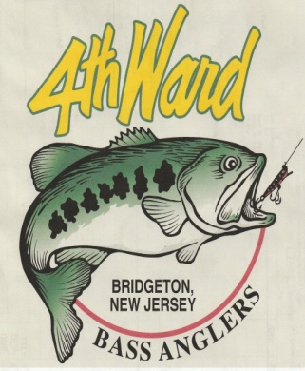
$80 ENTRY FEE – LUNKER FEE INCLUDED
$$$Cash only at Ramp$$$
80% Payback*, 100% Lunker
$10.00 from each entry goes to Make-A-Wish Foundation
5 Fish Limit – 12” Minimum

Launch site will be the State ramp on Hawks Bridge Rd (Rt. 540)
Boater Name ______________________ Boater Cell Phone No. _________________
Boater Signature ________________________________________________________
Partner Name ______________________
Partner Signature _______________________________________________________
Having acquainted ourselves with the rules and regulations of this tournament, I hereby waive and release the 4th Ward Bass Anglers club its officers, sponsors and other contestants from all damages, claims, demands, costs or expenses relating to injury of any person or property which I may sustain or cause by participating in this tournament. I also understand that I will forfeit my entry fee if I fail to appear at the specified tournament date and time.

NO. FISH: ___ PENALTY: ______ WEIGHT: _______

LUNKER: _____ LENGTH: _______

BOAT #: ___________

4TH WARD BASS ANGLERS

OPEN BUDDY TOURNAMENT RULES

- All boats must be equipped with a working livewell.
- State regulations must be adhered to with respect to minimum size and creel limit (5 fish limit or 3 fish at NJ trophy lakes).
- No culling of dead fish. All dead fish must be weighed in.
- No live bait.
- No trolling.
- One rod per person in use at any time.
- Cannot leave the boat to land a fish.
- No one is permitted to leave the boat during tournaments except for emergency situations.
- Salem Canal Off Limits: No passing under the westbound Rt 40 bridge on Game Creek. No proceeding past the train bridge (No Trespassing Sign) near Dupont.
- No fishing within 25 yards of an anchored boat. (Trolling motor must be in the stowed position.)
- For lakes where outboard motor use is permitted, life vests must be worn at all times the outboard motor is running.
- A .50 lb (8 oz) penalty will be assessed for every minute late. Disqualified after 5 minutes.
- A .50 lb (8 oz) penalty will be assessed for every dead fish.
- No courtesy measurements by will be done by tournament officials. Once fish are handed over for measuring/weighing, they become official.
- Short fish penalty = Team will lose their heaviest fish for that day and the short fish weight will not count.
- Lunker ties will be broken by length of team’s lunker.
- Total weight ties will be broken by the weight of the team’s lunker, then by length of team’s lunker if necessary.
- Only largemouth and smallmouth bass are eligible.
- All disputes will be decided by the tournament officials at the tournament site.

